**POTUNGAN NATIONAL HIGH SCHOOL**

**BARANGAY POTUNGAN, DAPITAN CITY, ZAMBOANGA DEL NORTE, 7101**



**FACTORS AFFECTING THE STRESS LEVEL**

**AMONG GRADE 12 HUMSS-A IN**

**POTUNGAN NATIONAL HIGH SCHOOL**

**GROUP 6 AND 8**

**GRADE 12 HUMSS-A**

**SUBMITTED TO MR. CHRIS REY RODRIGUEZ**

**IN PARTIAL FULFILLMENT OF THE REQUIREMENTS**

**FOR RESEARCH INQUIRIES, INVESTIGATION AND IMMERSION**

**JUNE 2023**

**TABLE OF CONTENTS**

Title Page

Abstract

Table of Contents

I. Introduction

II. Literature Review

III. Methodology

IV. Results and Discussion

V. Conclusion

VI. References

Appendices

**I. Introduction**

Stress is a common experience characterized by the perception of emotional or physical tension. It is the body's natural reaction to challenges or demands. While stress can have positive effects and motivate individuals, prolonged or excessive stress can lead to severe health conditions. Academic stress, specifically among Grade 12 HUMSS-A students at Potungan National High School, is a significant concern as it can impact their academic performance.

As students progress through their academic journey, they often encounter various stressors that can significantly impact their well-being and academic performance. Among the different grade levels, Grade 12 is a crucial period for students as they face the challenges of completing their high school education and making important decisions regarding their future pathways. In this context, Grade 12 students in the Humanities and Social Sciences strand Section A (HUMSS-A) at Potungan National High School experience a unique set of stressors that may affect their stress levels and overall well-being. Understanding the factors that contribute to their stress is essential for designing effective interventions and support systems.

While stress is a normal part of life, excessive and prolonged stress can have detrimental effects on students' physical and mental health, as well as their academic performance. Grade 12 HUMSS-A students at Potungan National High School may face various stressors related to academic expectations, extracurricular activities, personal relationships, and future uncertainties. However, there is a gap in knowledge regarding the specific factors that significantly contribute to their stress levels. Therefore, it is crucial to investigate and identify these factors to develop targeted interventions and support mechanisms for this student population.

The main objectives of this study are to identify the main sources of stress among Grade 12 HUMSS-A students, explore the academic stressors specific to this student population, examine the impact of stress on their physical health, assess the role of family relationships in their stress levels, and provide insights and recommendations for the development of interventions and support systems to mitigate stress and promote their well-being.

This research holds significant importance for various stakeholders involved in the education system. By identifying the factors that affect stress levels among Grade 12 HUMSS-A students, educators and school administrators can gain valuable insights into the specific challenges faced by these students. This knowledge can inform the development of targeted interventions, curriculum modifications, and support mechanisms to alleviate stress and enhance students' well-being. Additionally, understanding the impact of stress on physical health and the role of family relationships can guide the implementation of holistic approaches to promote overall student wellness. Ultimately, this study aims to contribute to the improvement of the academic environment and the quality of education provided to Grade 12 HUMSS-A students at Potungan National High School.

This study aims to address the gap in knowledge regarding the specific factors contributing to stress levels among Grade 12 HUMSS-A students at Potungan National High School. By investigating the sources of stress, academic stressors, impact on physical health, and role of family relationships, this research seeks to provide valuable insights and recommendations for interventions and support systems to enhance the well-being and academic performance of Grade 12 HUMSS-A students.

**II. Literature Review**

**Conceptual Framework**

In understanding the factors affecting stress levels among Grade 12 HUMSS-A students, it is important to establish a conceptual framework that guides the exploration of these factors. This framework takes into account the interplay between individual characteristics, academic environment, social relationships, and personal experiences, which collectively contribute to the stress experienced by students.

**Stress: Definition and Types**

Stress is a perception of emotional or physical tension that arises from various challenges or demands in an individual's life. It can be categorized into two main types: eustress and distress. Eustress refers to positive stress that arises from fulfilling tasks and meeting goals, while distress refers to negative stress caused by overwhelming demands or difficulties.

**Academic Stress: Causes and Effects**

Academic stress is a specific type of stress experienced by students due to the demands and pressures of their academic responsibilities. Common causes of academic stress include examinations, assignments, time management challenges, high expectations from teachers and parents, peer pressure, and the pressure to achieve good grades. The effects of academic stress can manifest as anxiety, depression, decreased academic performance, sleep disturbances, and negative impacts on overall well-being.

**Physical Health Implications of Stress**

Stress can have significant implications for physical health. When individuals experience chronic stress, it can lead to the dysregulation of various physiological systems, such as the immune, cardiovascular, and endocrine systems. This dysregulation increases the risk of developing physical health problems, including cardiovascular diseases, weakened immune function, gastrointestinal disorders, and sleep disorders. Additionally, stress can impact individuals' health behaviors, such as decreased physical activity levels and poor dietary habits, further exacerbating the risk of physical health issues.

**Role of Family Relationships in Student Stress Levels**

Family relationships play a crucial role in the stress levels experienced by students. Supportive and positive family relationships can act as buffers against stress, providing emotional support, guidance, and a sense of security. On the other hand, strained or dysfunctional family relationships can contribute to increased stress levels among students. Factors such as parental expectations, conflicts within the family, lack of support, and financial difficulties can significantly impact students' stress levels and overall well-being.

**Previous Research on Student Stress**

Previous research has extensively explored the factors affecting stress levels among students. Studies have identified various stressors, including academic pressures, personal relationships, future uncertainties, and the impact of stress on mental health and academic performance. Additionally, research has examined the effectiveness of interventions and support systems in reducing student stress and promoting well-being. These studies provide valuable insights and serve as a foundation for understanding and addressing stress among Grade 12 HUMSS-A students.

The literature review highlights the conceptual framework of the study and provides an overview of stress, academic stress, its effects on physical health, the role of family relationships, and existing research on student stress. This review sets the foundation for further investigation into the specific factors influencing stress levels among Grade 12 HUMSS-A students at Potungan National High School.

**III. Methodology**

**Research Design**

This study will employ a cross-sectional research design. The cross-sectional design allows for data collection at a specific point in time to gather information about the factors influencing stress levels among Grade 12 HUMSS-A students. This design will enable the researchers to analyze the relationship between variables and draw conclusions about the factors affecting stress levels in this particular student population.

**Participants**

The participants of this study will be Grade 12 HUMSS-A students enrolled at Potungan National High School. A purposive sampling technique will be used to select participants who meet the inclusion criteria, ensuring representation from different backgrounds and experiences within the target population. The research study included a sample size of 20 Grade 12 HUMSS-A students, selected from the class. The sample size was considered appropriate for providing meaningful insights within the study's objectives.

**Data Collection Instruments (Survey Questionnaire)**

A survey questionnaire will be the primary data collection instrument used in this study. The questionnaire will be designed to gather information about the various factors that contribute to stress levels among Grade 12 HUMSS-A students. It will consist of both closed-ended and open-ended questions, allowing participants to provide quantitative ratings as well as qualitative insights about their stressors, academic experiences, and family relationships. The questionnaire will be pilot tested to ensure its validity and reliability.

**Data Collection Procedure**

The data collection procedure will be conducted online using a Google Docs link sent to the participants. Prior permission will be obtained from the school administration to conduct the research. The teachers will assist in coordinating the data collection process and scheduling a convenient time for participants to complete the survey. Clear instructions will be provided to the participants on how to access and fill out the questionnaire. Confidentiality and anonymity of the responses will be ensured, and the researchers will be available to address any queries or concerns from the participants.

**Data Analysis Techniques**

The collected data will undergo analysis using descriptive statistics and percentages to present and interpret the findings. This analysis will summarize and describe the demographic characteristics of the participants, as well as the identified stress factors.

The methodology outlined in this study will provide a systematic approach to collect and analyze data to understand the factors affecting stress levels among Grade 12 HUMSS-A students. The use of a survey questionnaire will enable the researchers to gather comprehensive information, while the chosen data analysis techniques will facilitate the exploration of relationships and patterns within the data.

**IV. Results and Discussions**

**Demographic Profile of Grade 12 HUMSS-A Students**

This section presents an overview of the demographic characteristics of the selected 20 Grade 12 HUMSS-A students involved in the study. It includes information such as gender distribution, age range, socioeconomic background, and family structure. The analysis of these demographic factors provides insights into the sample composition and helps contextualize the subsequent findings.

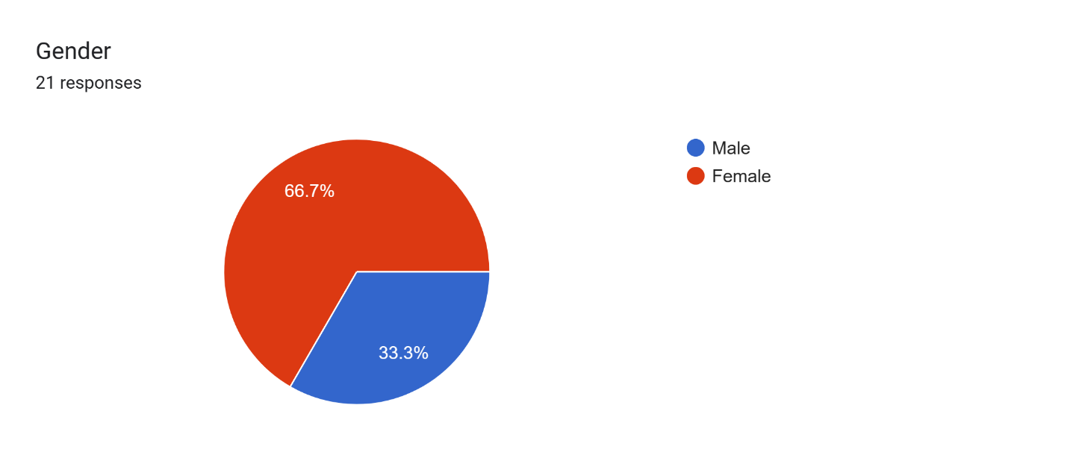

20 respondents

Gender

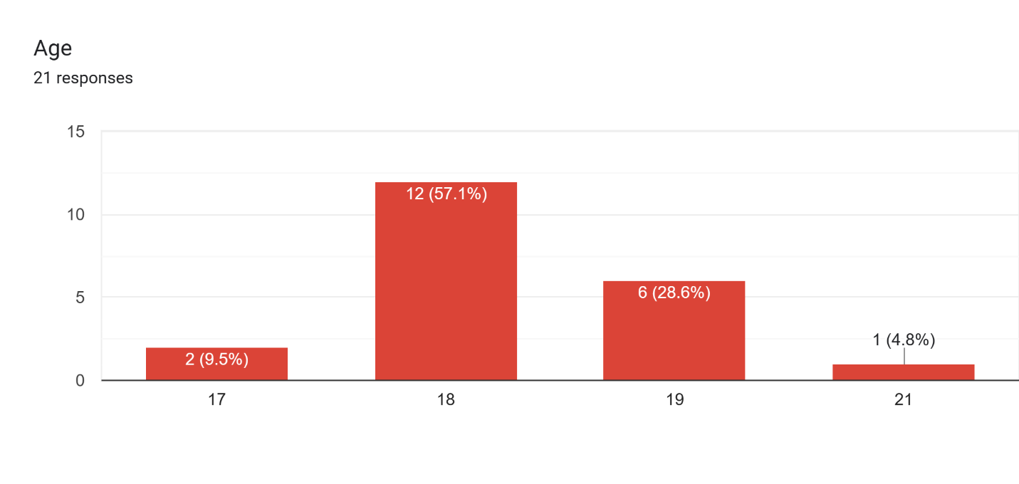

Age



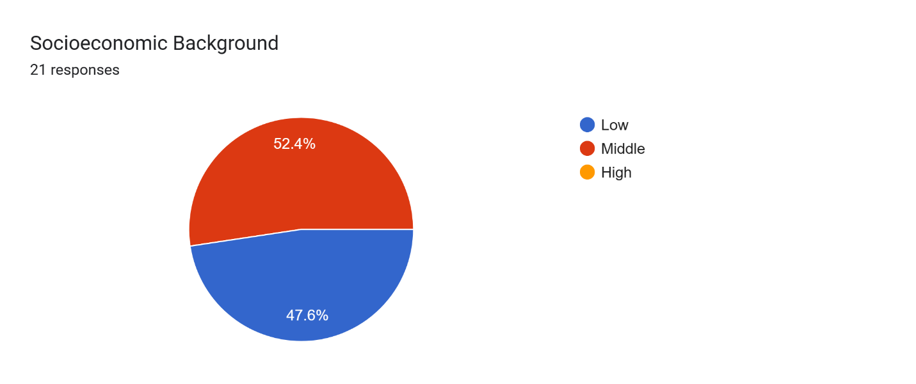

Socioeconomic Background

Family Structure

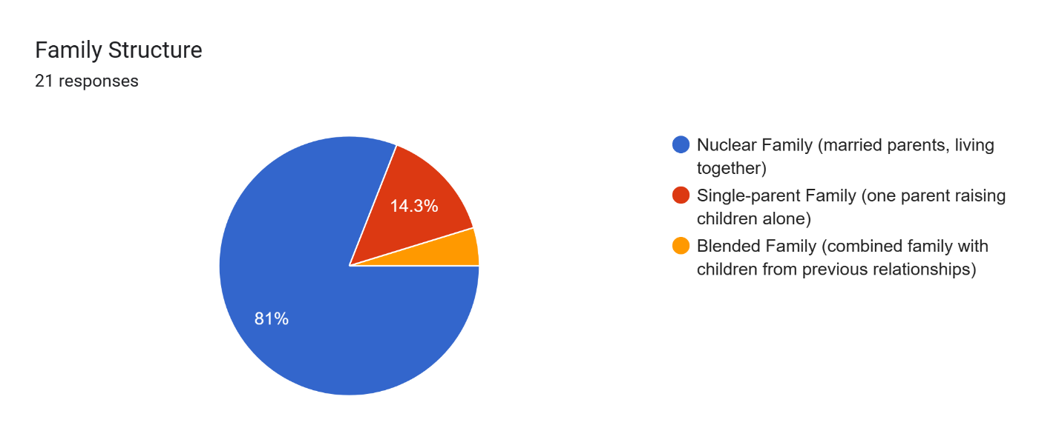

4.8%

The majority of the participants were male, accounting for 66.7% of the total, while females represented 33.3%. In terms of age, the highest percentage was observed among 18-year-olds, comprising 57.1% of the participants. The age group of 17-year-olds accounted for 9.5%, followed by 19-year-olds at 28.6%, and a small portion of 4.8% represented by a 21-year-old student. Regarding socioeconomic background, approximately half of the students (52.4%) belonged to the middle-income category, while 47.6% reported a low-income background. Furthermore, the majority of participants (81%) came from nuclear families, while 14.3% were from single-parent families, and a small proportion (4.8%) identified as belonging to blended families.

**Sources of Stress among Participants**

This section explores the various sources of stress experienced by Grade 12 HUMSS-A students. It examines factors such as academic demands, time management challenges, peer pressure, future uncertainties, extracurricular activities, and personal relationships. This analysis brings clarity to the main factors that contribute to the stress levels experienced by the participants by identifying their primary stressors.

Indicate the main sources of stress you experience as a Grade 12 HUMSS-a student. (Mark all that apply)

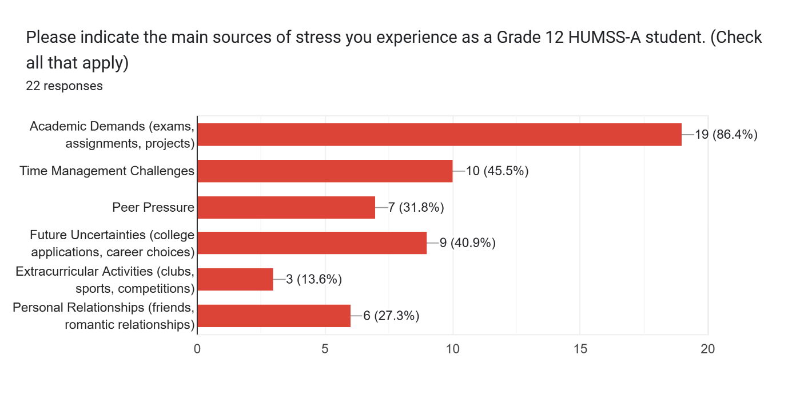

The findings indicate that the main sources of stress experienced by Grade 12 HUMSS-A students are primarily related to academic demands. A significant majority of respondents (86.4%) identified exams, assignments, and projects as major stressors. Time management challenges were also reported by 45.5% of participants, highlighting the difficulty in balancing multiple academic responsibilities. Other notable sources of stress include future uncertainties, such as college applications and career choices (40.9%), as well as personal relationships (27.3%). Peer pressure and extracurricular activities were cited by a smaller proportion of students. These findings suggest that academic pressures and concerns about the future play a significant role in contributing to stress levels among Grade 12 HUMSS-A students.

**Academic Stressors and their Impact on Stress Levels**

This section focuses on the academic stressors faced by Grade 12 HUMSS-A students and their impact on their overall stress levels. It examines factors such as examinations, assignments, time pressure, high expectations from teachers, and pressure to achieve good grades. The analysis investigates the relationship between these academic stressors and the perceived stress levels reported by the participants.

On a scale of 1 to 5, with 1 being low and 5 being high, rate the level of stress you experience from each of the following academic stressors:

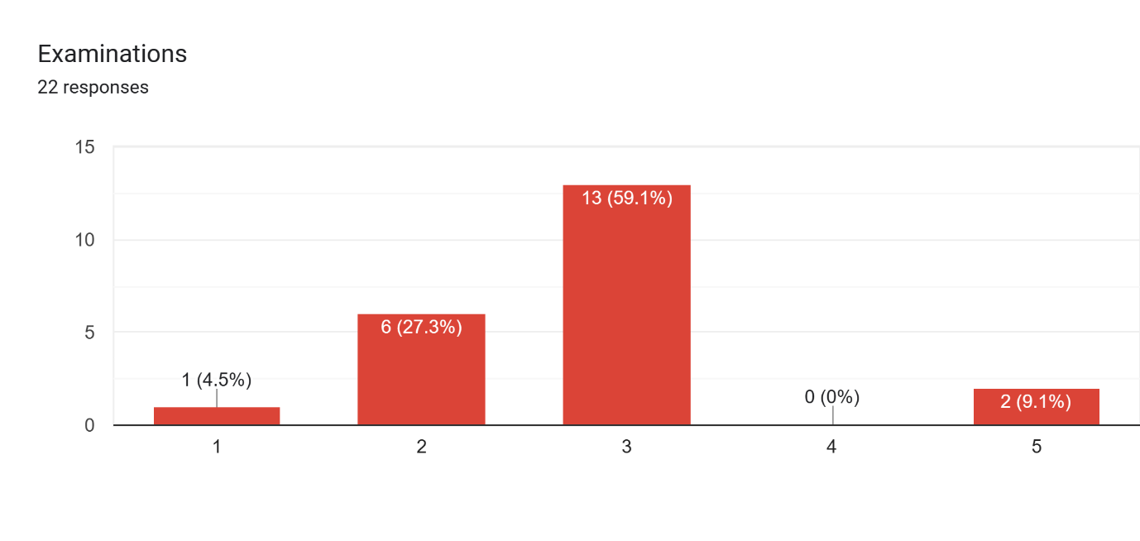

Examinations

4 (27.3%)

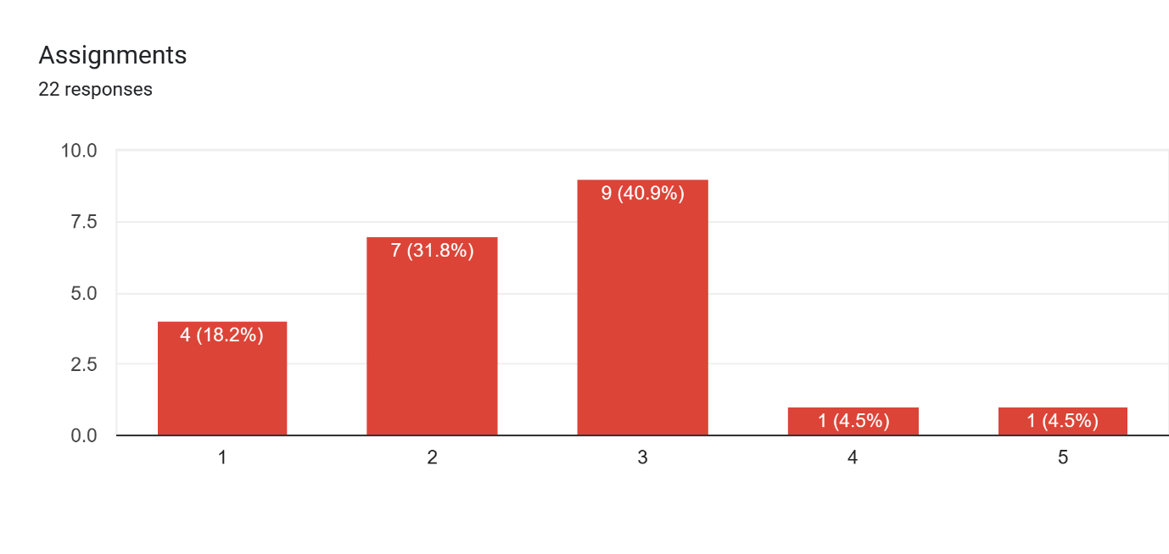

Assignments

8 (40.9%)

6 (31.8%)

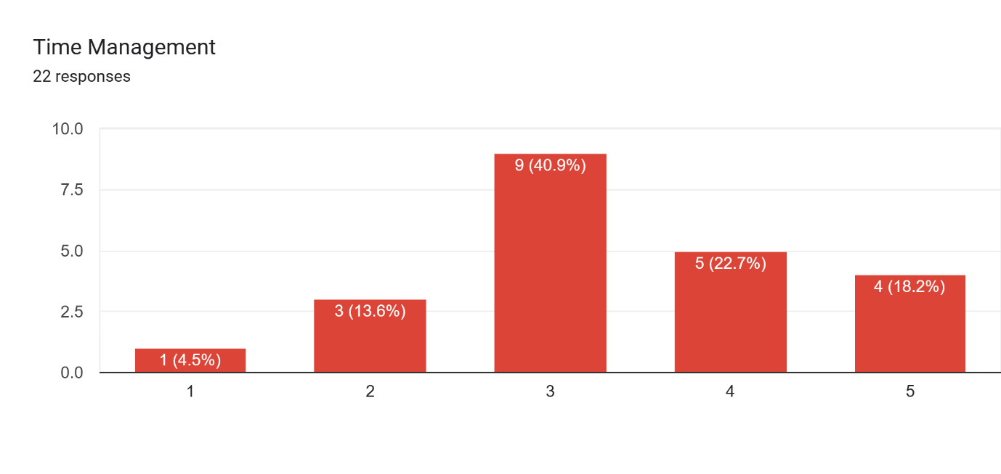

Time Management

7 (40.9%)

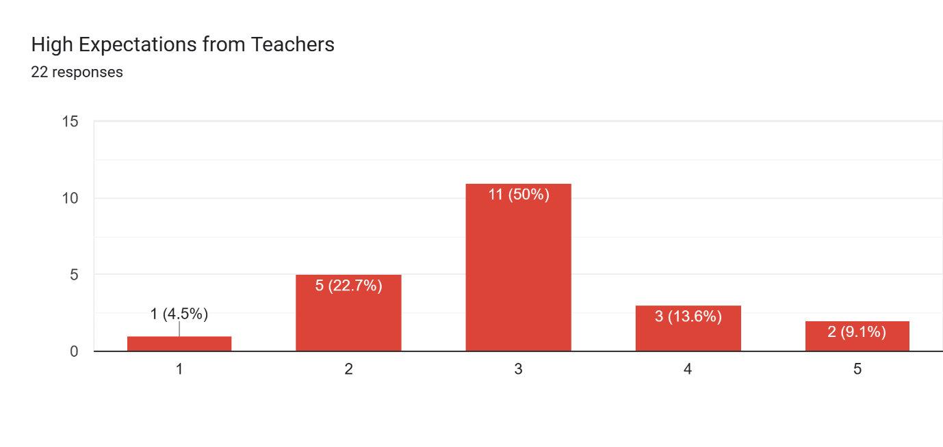

High Expectations from Teachers

9 (50%)

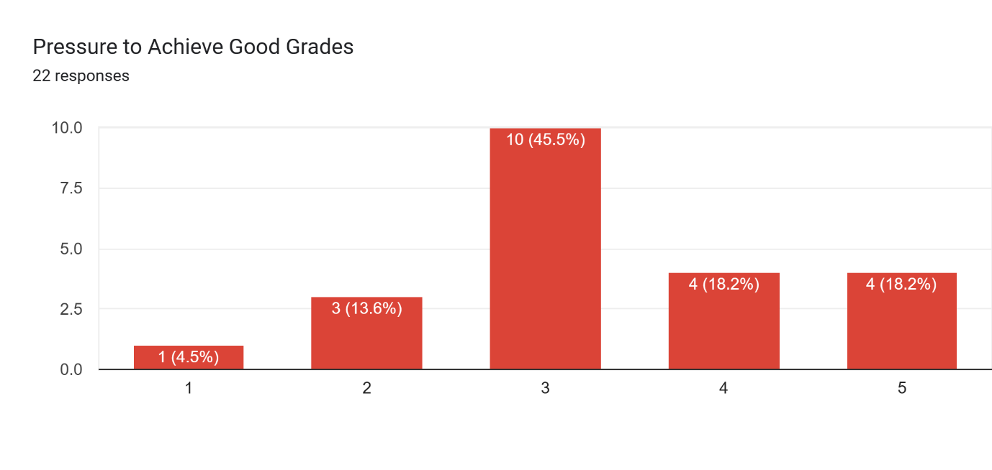

Pressure to Achieve Good Grades

8 (45.5%)

The findings reveal the perceived levels of stress among Grade 12 HUMSS-A students regarding various academic stressors. When rating the stress levels on a scale of 1 to 5, the majority of respondents indicated moderate stress for examinations (59.1%) and assignments (40.9%). Time management was also a significant stressor, with 40.9% of students reporting moderate stress. High expectations from teachers and pressure to achieve good grades were found to be moderately stressful for 50% and 45.5% of participants, respectively. These results suggest that Grade 12 HUMSS-A students experience varying levels of stress across different academic stressors, highlighting the need for effective stress management strategies and support systems.

**Relationship between Stress and Physical Health**

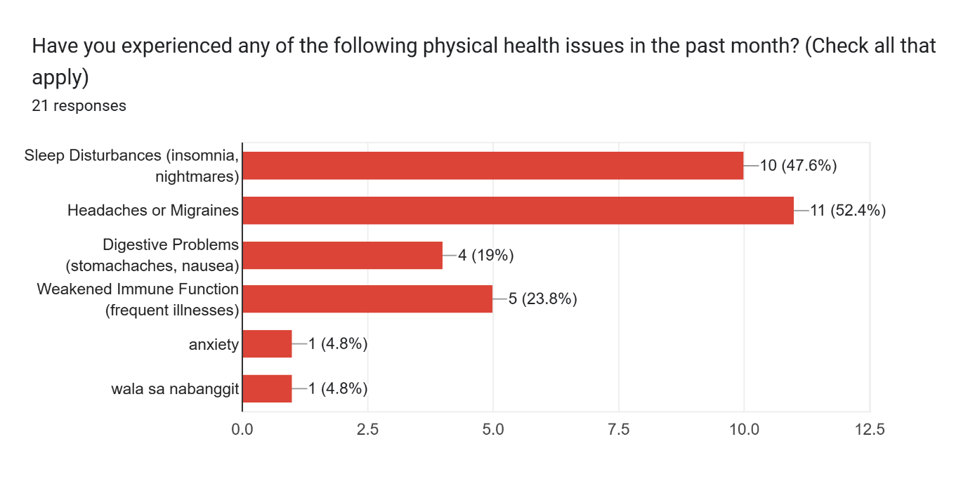This section investigates the relationship between stress and physical health among Grade 12 HUMSS-A students. It examines the prevalence of physical health issues, such as sleep disturbances, headaches, digestive problems, and weakened immune function, and explores how these issues may be influenced by stress. The analysis provides insights into the potential impact of stress on the students' physical well-being.

Have you experienced any of the following physical health issues in the past month? (Mark all that apply)

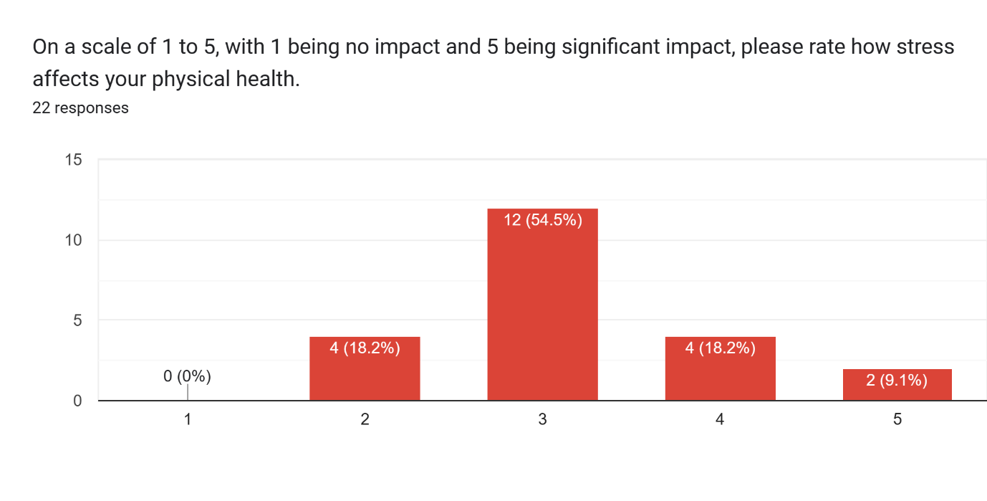

On a scale of 1 to 5, with 1 being no impact and 5 being significant impact, rate how stress affects your physical health.

10 (54.5%)

A significant number of participants reported experiencing physical health issues in the past month. The most common physical health problems were sleep disturbances, reported by 47.6% of respondents, and headaches or migraines, reported by 52.4% of respondents. Digestive problems, weakened immune function, and anxiety were also mentioned by a smaller percentage of participants. When assessing the impact of stress on physical health, the majority of respondents (54.5%) rated it as having a moderate impact (score of 3 on a scale of 1 to 5). A smaller proportion reported higher or lower levels of impact.

**Influence of Family Relationships on Student Stress Levels**

This section explores the influence of family relationships on the stress levels of Grade 12 HUMSS-A students. It examines the quality of family relationships, the presence of academic pressure from family, and the level of support received from family regarding academic and personal life. The analysis investigates how these factors may contribute to or mitigate student stress levels.

How would you describe the quality of your family relationships?

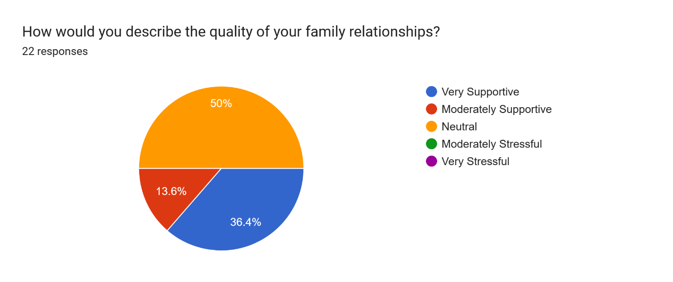

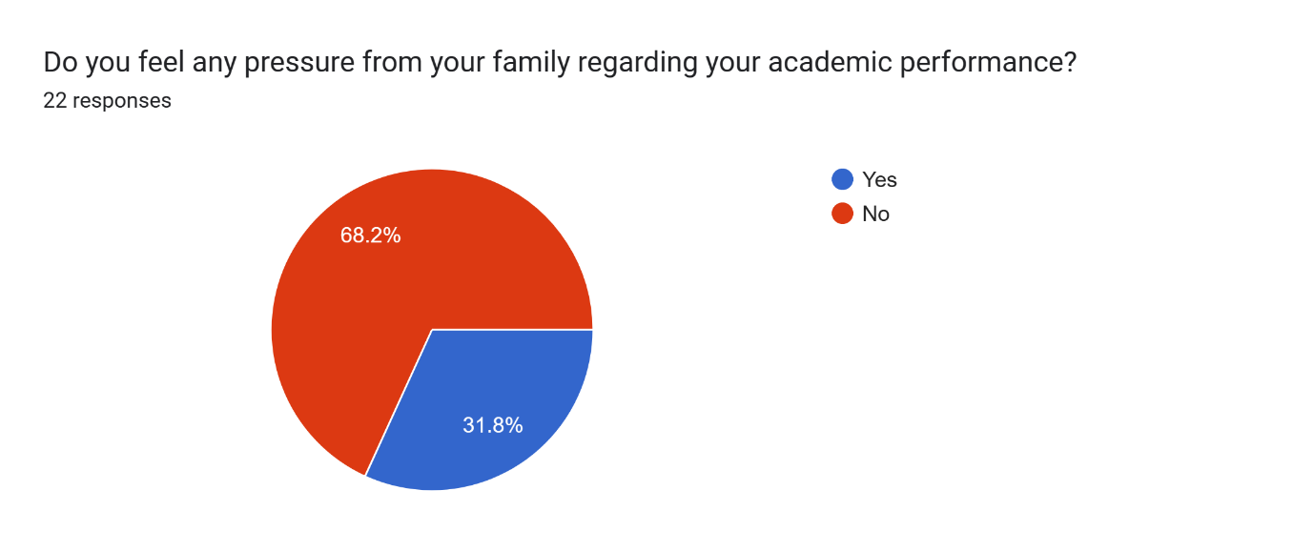

Do you feel any pressure from your family regarding your academic performance?

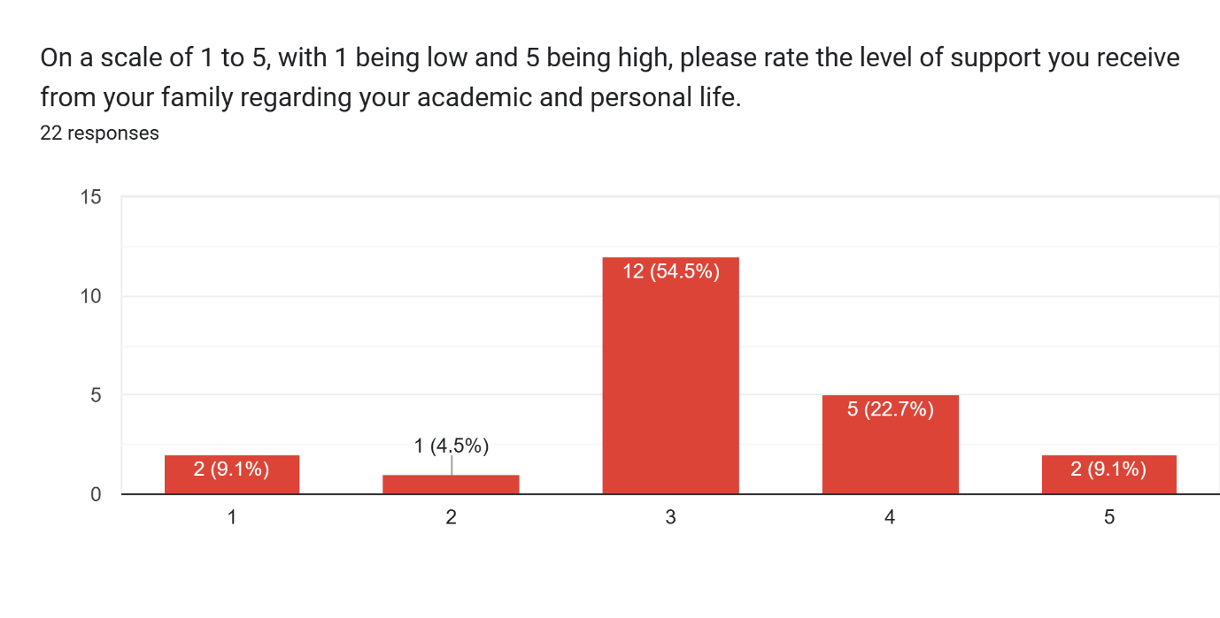

On a scale of 1 to 5, with 1 being low and 5 being high, please rate the level of support you receive from your family regarding your academic and personal life.

10 (54.5%)

The findings indicate that the majority of participants (50%) reported a neutral quality of family relationships, while 36.4% described their family relationships as very supportive, and 13.6% viewed them as moderately supportive. In terms of academic pressure, 31.8% of respondents felt pressure from their family regarding their academic performance, while the majority (68.2%) did not. When rating the level of support received from their family, 54.5% of participants rated it as a moderate level (score of 3 on a scale of 1 to 5), while smaller percentages indicated lower or higher levels of support.

**Key Findings**

* Sources of Stress

The main sources of stress among Grade 12 HUMSS-A students were identified as academic demands, time management challenges, future uncertainties, and personal relationships. Academic demands, including exams, assignments, and projects, were reported by the majority of participants (86.4%) as a significant stressor.

* Academic Stressors and Impact

When rating the level of stress from specific academic stressors, participants reported higher stress levels in relation to examinations and assignments, while time management received a moderate level of stress. This suggests that the pressure associated with exams and assignments may have a greater impact on students' stress levels compared to time management challenges.

* Relationship between Stress and Physical Health

The majority of participants (54.5%) indicated that stress has a moderate impact on their physical health. Additionally, common physical health issues reported by students included sleep disturbances and headaches/migraines. These findings suggest a potential link between stress and physical health problems among Grade 12 HUMSS-A students.

* Influence of Family Relationships

The quality of family relationships varied among participants, with 50% reporting a neutral quality and 36.4% describing their family relationships as very supportive. In terms of academic pressure, a significant proportion of students (31.8%) felt pressure from their families regarding their academic performance.

**Discussion**

The findings highlight the significant role of academic demands as a major stressor among Grade 12 HUMSS-A students. These stressors can negatively impact students' well-being and academic performance. The high prevalence of stress related to exams and assignments suggests the need for interventions or support mechanisms to help students cope with academic pressures effectively.

The reported physical health issues, such as sleep disturbances and headaches/migraines, further emphasize the detrimental impact of stress on students' overall well-being. These findings align with existing literature on the association between stress and physical health problems among adolescents. It underscores the importance of addressing stress management strategies and promoting a holistic approach to student well-being.

The quality of family relationships also emerged as a crucial factor influencing students' stress levels. While some students reported very supportive family relationships, others reported a more neutral quality. The presence of academic pressure from families indicates the need for open communication and support from parents or guardians to ensure a healthy and balanced approach to academic expectations.

Overall, the findings suggest the need for comprehensive interventions and support systems within the educational environment to address the identified stressors. This may include implementing stress management programs, promoting effective time management skills, and fostering open communication between students, educators, and families. By addressing these factors, schools can create a supportive environment that facilitates student well-being and academic success.

**V. Conclusion**

In conclusion, this study provides valuable insights into the factors affecting the stress levels of Grade 12 HUMSS-A students. The findings indicate that academic demands, time management challenges, future uncertainties, and personal relationships are significant stressors for these students. Examinations and assignments were identified as particularly stressful, highlighting the need for effective coping strategies and support mechanisms to help students manage these academic pressures.

The study's findings have important implications for both educational institutions and stakeholders. Firstly, schools should consider implementing stress management programs and interventions that address the identified stressors. These initiatives can provide students with the necessary tools and resources to cope with academic demands and enhance their overall well-being. Additionally, fostering a supportive environment that encourages open communication between students, educators, and families is crucial in alleviating academic pressure and promoting positive mental health.

While this study sheds light on the stressors experienced by Grade 12 HUMSS-A students, it is essential to acknowledge its limitations. The study was conducted in a specific high school, which may limit the generalizability of the findings to other contexts. Additionally, self-report measures were used, which can be subject to response biases. Future research should consider expanding the sample size, including participants from diverse backgrounds, and utilizing mixed methods approaches to gain a more comprehensive understanding of student stress levels.

This study underscores the importance of addressing student stress levels and promoting their well-being in the educational setting. By understanding the specific stressors and their impacts, schools and stakeholders can implement targeted interventions and support systems that enhance student resilience and academic success. Through collaborative efforts, we can create a nurturing environment that prioritizes student mental health and fosters their holistic development.

**VI. References**

Geeta Jain, & Manisha Singhai. (2018). Academic Stress and its Sources among Higher Secondary School Students. IOSR Journal of Humanities and Social Science, 23(10), 60-65.

Jeanne Segal Ph.D., Melinda Smith M.A., & Lawrence Robinson. (2023). Stress Symptoms, Signs, and Causes. HelpGuide. Retrieved from <https://www.helpguide.org/articles/stress/stress-symptoms-signs-and-causes.htm>

L. Vijayashree, & Shishira Srinivasa. (2021). Academic Stress among Higher Secondary School Students. International Journal of Indian Psychology, 9(2), 124-132.

Narassapa Kumarswamy. (2013). Stress, Anxiety, and Depression among College Students - A Brief Review. International Journal of Information Research and Review, 1(4), 27-34.

Sults-kolehmainen, M., & Sinha, R. (2014). The Effects of Stress on Physical Activity and Exercise. Sports Medicine, 44(1), 81-121.

Zhonglu Li, & Zeqi Qui. (2018). How Family Relationships Affect Students' Academic Achievement? The Mediating Effect of Learning Motivation. Frontiers in Psychology, 9, 1553.

**Appendices**

**Appendix A**

**Survey Questionnaire**

[**https://forms.gle/WThohLGtnT7rs9SeA**](https://forms.gle/WThohLGtnT7rs9SeA)

* Section 1: Demographic Information

1. Gender: [ ] Male [ ] Female [ ] Other

2. Age: _______________

3. Socioeconomic Background: [ ] Low-income [ ] Middle-income [ ] High-income

4. Family Structure: [ ] Nuclear family [ ] Single-parent family [ ] Blended family [ ] Other (please specify: ____________)

* Section 2: Sources of Stress

5. Please indicate the main sources of stress you experience as a Grade 12 HUMSS-A student. (Check all that apply)

[ ] Academic demands (exams, assignments, projects)

[ ] Time management challenges

[ ] Peer pressure

[ ] Future uncertainties (college applications, career choices)

[ ] Extracurricular activities (clubs, sports, competitions)

[ ] Personal relationships (friends, romantic relationships)

[ ] Other (please specify: ____________)

6. On a scale of 1 to 5, with 1 being low and 5 being high, please rate the level of stress you experience from each of the following academic stressors:

a) Examinations: ________

b) Assignments: ________

c) Time pressure: ________

d) High expectations from teachers: ________

e) Pressure to achieve good grades: __________

* Section 3: Relationship between Stress and Physical Health

7. Have you experienced any of the following physical health issues in the past month? (Check all that apply)

[ ] Sleep disturbances (insomnia, nightmares)

[ ] Headaches or migraines

[ ] Digestive problems (stomachaches, nausea)

[ ] Weakened immune function (frequent illnesses)

[ ] Other (please specify: ____________)

8. On a scale of 1 to 5, with 1 being no impact and 5 being significant impact, please rate how stress affects your physical health.

________

* Section 4: Influence of Family Relationships on Stress Levels

9. How would you describe the quality of your family relationships?

[ ] Very supportive

[ ] Moderately supportive

[ ] Neutral

[ ] Moderately stressful

[ ] Very stressful

10. Do you feel any pressure from your family regarding your academic performance?

[ ] Yes

[ ] No

11. On a scale of 1 to 5, with 1 being low and 5 being high, please rate the level of support you receive from your family regarding your academic and personal life.

________

* Section 5: Additional Comments

12. Are there any additional factors or concerns related to stress that you would like to share? (Open-ended response)

**Appendix B**

**Contributors**

Calimpong, Jhon Mark

Dagpin, John Paul

Puliran, Froiland Jade

Acal, Remdel Jim

Saja, Joshua

Bagor, Angeline

Ecas, Yassmine

Pobadora, Rossa

Millalos, Sheena

Biolango, Jane Rose

Arenos, Mary Joy

Palad, Raffy

Alabata, Jamaica

Caylaluad, Frietch Joy

Baguio, Aldemer